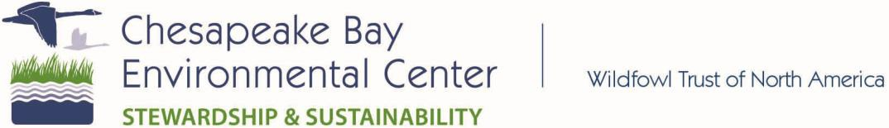

SPONSORSHIP OPPORTUNITIES
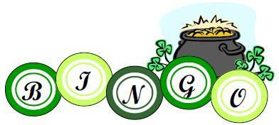
9th Annual CBEC Irish Bingo Night
March 14, 2020 • Doors open at 6:00 Chesapeake Bay Environmental Center CBEC Needs Your Support!
Levels of Sponsorship:
- Pot o’ Gold ($250) - Title sponsor. Company logo in Bingo hall at event and recognition in CBEC e-newsletter and website. Four tickets to Bingo, six entries into a special door prize at the event.
- Lucky Leprechaun ($100) - Table sponsor. Company information at one table at the event, recognition at the event and on CBEC website. Two tickets to Bingo and four entries into a special door prize at the event.
- Shamrock ($50) - Prize sponsor! 1 ticket to Bingo. Recognition at the event and on CBEC website. Two entries into a special door prize at the event.

Business Name:

Contact Name:

Email: Phone:

Address:

City/State/Zip:

Amount donated: $

*CBEC is a 501(c)3 organization and your donation is tax deductible to the extent allowed by law.*
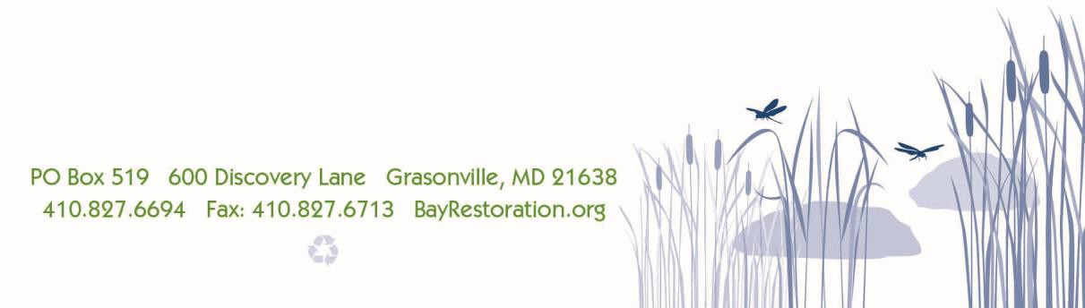
--Make check payable to CBEC. Mail to P.O. Box 519 Grasonville, MD 21638, give to a CBEC volunteer, or drop off at 600 Discovery Lane.--

