Surface Runoff Before and After Development
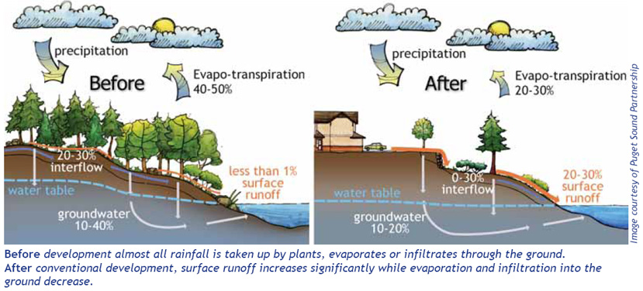
Source: http://www.ecy.wa.gov/washington_waters/images/WaterCycle.jpg

What are impervious surfaces and why are they a problem?
Impervious surfaces are paved or hardened surfaces that do not allow water to pass through. Roads, rooftops, sidewalks, pools, patios and parking lots are all impervious surfaces.

According to the U.S. Environmental Protection Agency (EPA), the presence of roads, rooftops and other impervious surfaces in urban areas means a typical city block generates more than five times more runoff than a forested area of the same size.
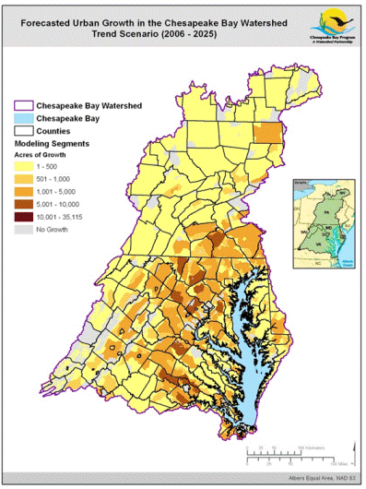
Source: https://www2.usgs.gov/climate_landuse/lcs/projects/lucbay.asp

