Our Wonderful Watershed

Next Generation Science Standards (grades 3-5)
5-ESS3-1 Earth and Human Activity
- Obtain and combine information about ways individual communities use science ideas to protect the Earth’s resources and environment.
- Activity: Day around the Bay and discussion
3-5-ETS1-1 Engineering Design
- Define a simple design problem reflecting a need or a want that includes specified criteria for success and constraints on materials, time, or cost.
- Activity: Wetland in a Pan

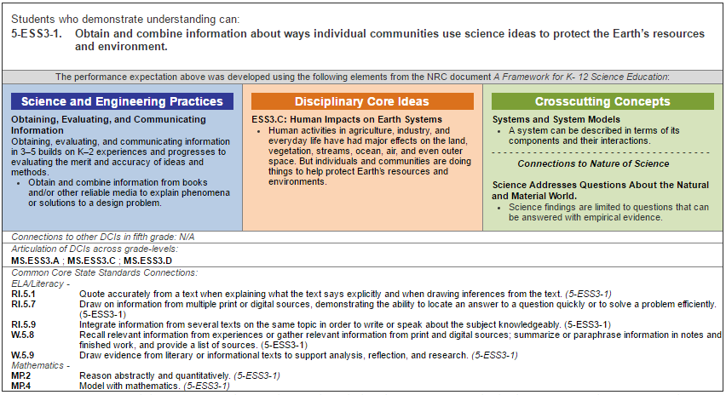
Materials:
- PowerPoint – CB Watershed Presentation
- Aquarium, film canisters, ingredients to refill canisters, story, paper towels
- Aluminum pans (10-15)
- Foil sheets
- Sponges
- Measuring cups (1 per group)
- 5 gallon bucket of soil
- 5 gallon bucket for water (for demonstration and cleaning sponges)
- 5 gallon bucket for waste
- Food coloring to demonstrate pollution – fertilizer or pesticides

Lesson Outline:
- PowerPoint – CB Watershed Presentation
- Follow the Rain
  - Trace tributaries that lead to CB
- Watershed
  - Definition – an area of land where all the water that is under it or drains off of it collects into the same place
  - Introduce CB watershed – 6 states
- Day around the Bay Story
  - With so many people living around the Bay (over 18 million), the Bay has started to become polluted. Who polluted the Bay? Let’s listen to the story to find out.
  - Materials – aquarium, film canisters, ingredients to refill canisters, story, paper towels
- One way is help the Bay is to plant wetlands! Let’s demonstrate.
  - Wetland in a Pan materials
    - Aluminum pans (10-15)
    - Foil sheets
    - Sponges
    - Measuring cups (1 per group)
    - 5 gallon bucket of soil
    - 5 gallon bucket for water (for demonstration and cleaning sponges)
    - 5 gallon bucket for waste
    - Food coloring to demonstrate pollution – fertilizer or pesticides
  - Students construct wetlands in a pan
    - Use foil to build landscape that slopes down to the Bay
    - Place 50 mL of dirt on landscape
    - Use sponges to construct a wetland to stop flow of dirt into the Bay
    - Add 100 mL of water to the Bay end of pan
    - Slowly pour 100 mL of water over the landscape and see what happens to the water in the Bay. Does any dirt get into the Bay? How do marshes help the quality or health of the water in the Bay?
    - Demonstrate what happens without marshes
    - Demonstrate what happens when you add “fertilizer” or “pesticides” to the soil by adding a drop of food coloring.
    - Cleanup
      - Wring out sponges over your model
      - Wring out sponges in bucket of clean water and put back in box of sponges
      - Dump water and soil into 5 gallon bucket
      - Rinse off foil in water bucket and place in bag to be recycled
      - Rinse out aluminum pan
- How can we help the Bay?
  - Brainstorm and discuss. Think-pair-share

